A few issues and bugs needed to be handled

First issue, in the home page, on the map theres dots of reported potholes, I want it so that when a user clicks on the dot it should show the details of the report, same with the map page. Still on the home page, where it reads “Vereeniging, Gauteng” change it to Emphuleni District because we only dealing with problems in that area. And remove the symbol next to it (that arrow pointing down)
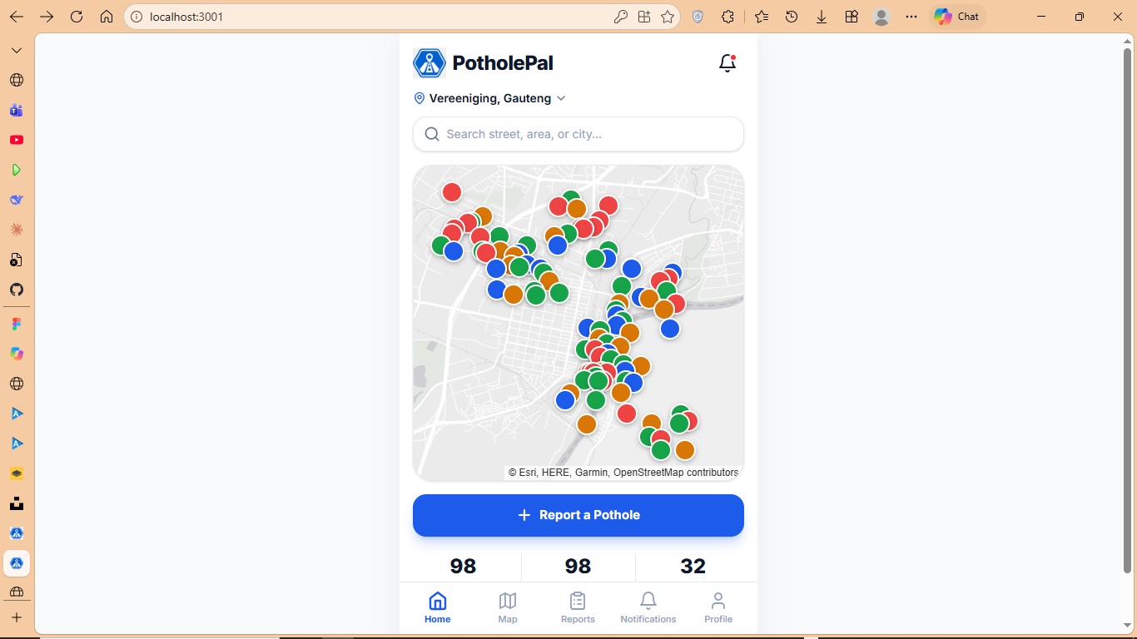
On the map page I have already mentioned about the interactive map where that when a user clicks on the dot it should show the details of the report. In addition to that on top of the search bar there’s an equalizer symbol there please remove it, it has no use to us, unless you find a use for it please remove it.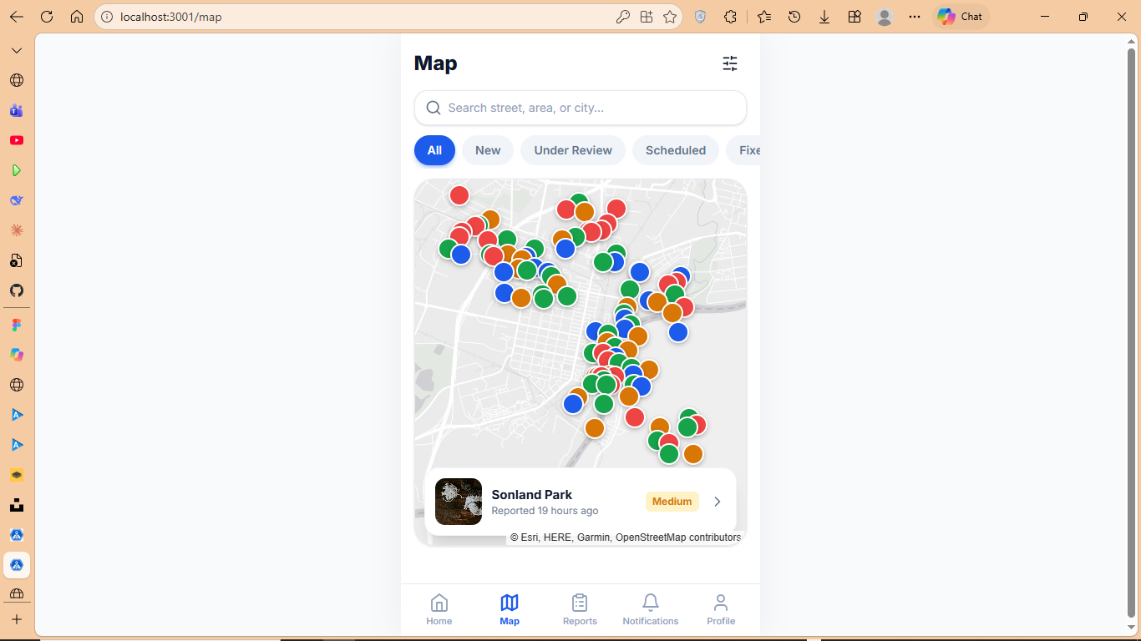
On the notifications page, our only issue is the cog button, it should either be removed or lead to notification but I suggest we just get rid of it.
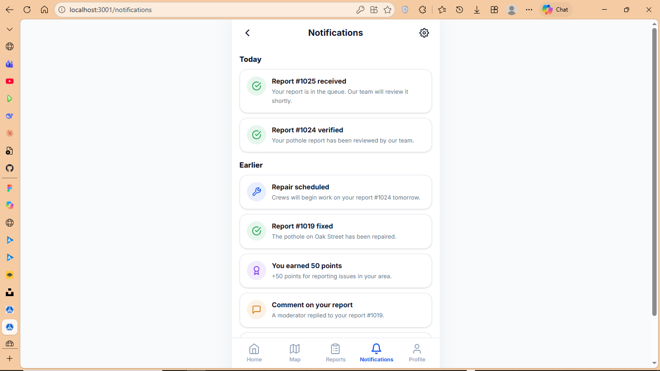

In the Profile page there’s quite a few issues mainly buttons, first thing is the cog button, it doesn’t do anything, My Impact doesn’t lead anywhere but its clickable, same as Leaderboard, Settings and Help & Support. Also please remove the Municipality portal from this page.
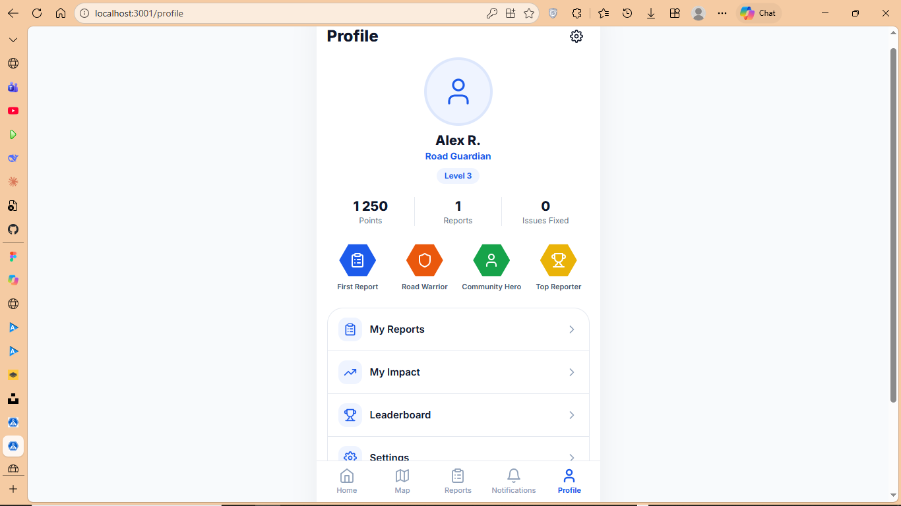
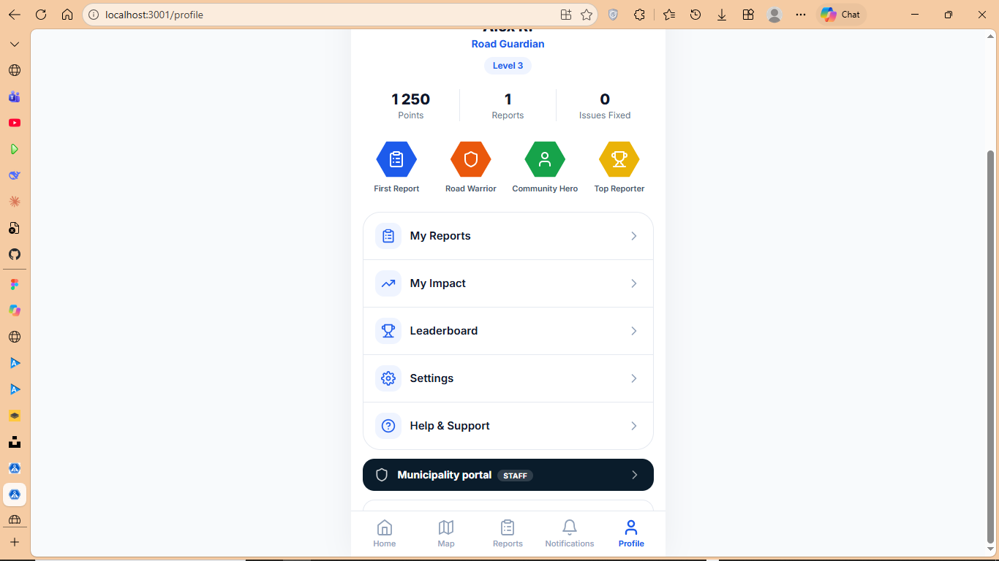

Now to when reporting a pothole. When it comes to capturing a photo, it should use the user’s camera on their device, so that whatever the camera is showing should be displayed in the frame. The rest of the buttons should work aswell like the flip and flash, it should be able to flip the camera and turn the flashlight on.
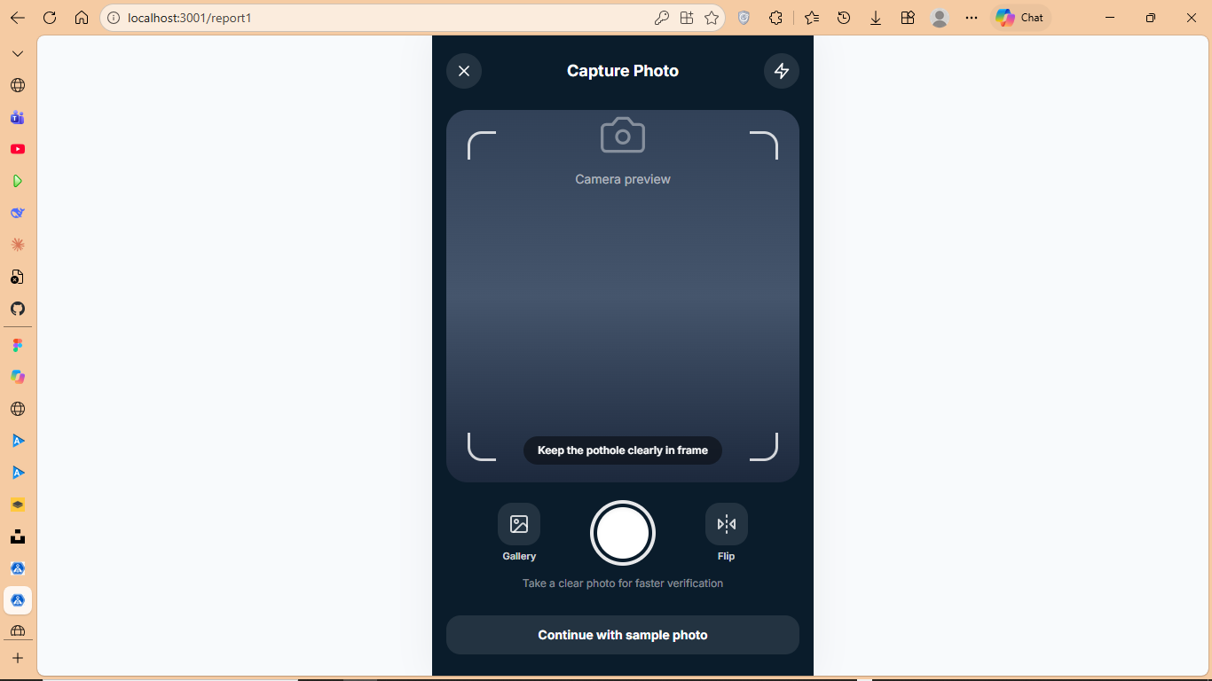
Lastly the map issue, this map is in accurate, either the pin or the map, because wherever you place the pin the location is wrong, where the pin is sitting right now is in Three Rivers but as you can see it reads Acorn Park, so that needs to be fixed aswell, and also the edit location button doesn’t work, users can’t edit their location. One more thing, when you use precise location/live location, it doesn’t point to where you are at the time.
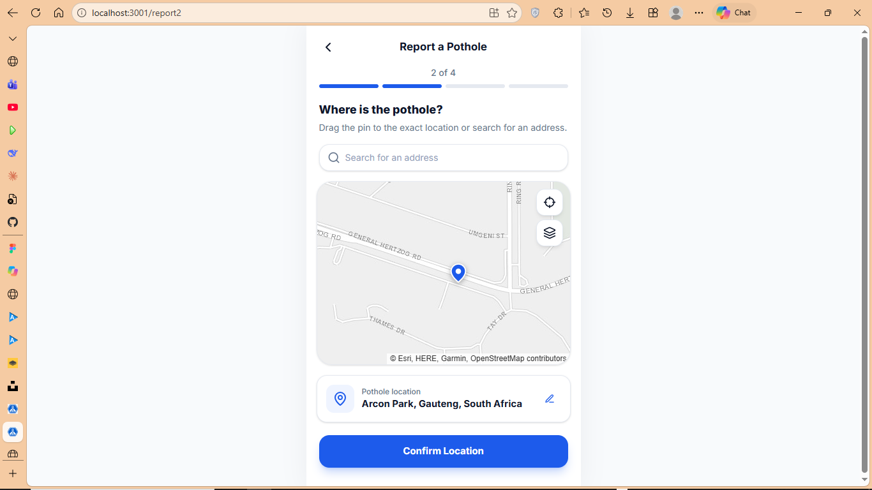

One more thing that should be clear is if users outside of the emphuleni district try to use the app and their location is outside of the emphuleni district, a message should pop up saying we don’t deal with issues outside of the emphuleni district

